PROJECT PROGRESS REPORT
(Progress Report no. 4)
1. Student Information
Student Name | PATEL MAN VISHNUBHAI.
Enrollment Number | 25IC03CA053
Program/Branch | Master Of Computer Applications
Semester | 3
Contact Number | 8849948963
Email ID | 25ic03ca053@ppsu.ac.in

2. Project Details
Type | Research Project
Department/Domain | MCA CA(DS/ML) / AI & ML
Mentor Name | Srikant Singh
Start Date | 08-06-2026
End Date | 03-10-2026

3. Work Progress Summary
- Project Title:
- OpenCV - Based System for Crack Identification and Width Estimation

- Initial Module Implementation Process:
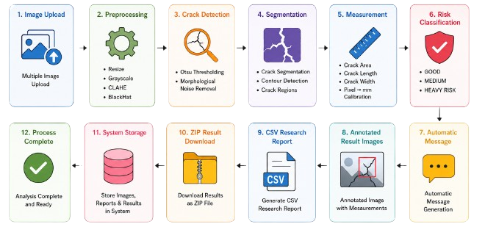
- Overall Coding Architecture:
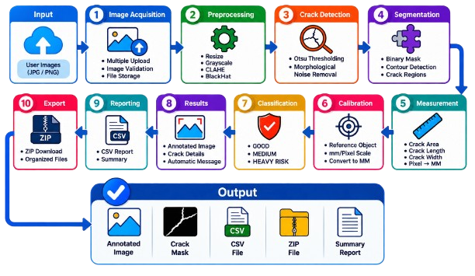

- Code:
  - Library Installation:
Code:
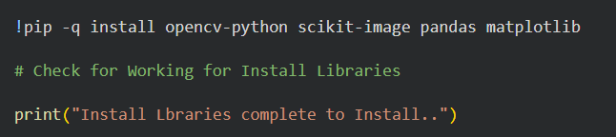
Output:
  - Import Libraries:
Code:
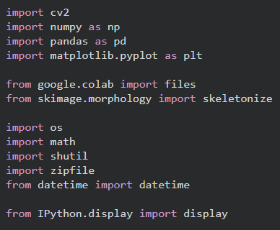
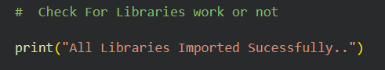
Output:

  - Project Configuration:
Code:
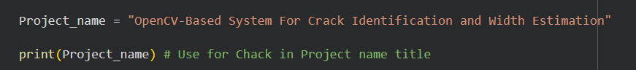
Output:
4. Tasks Accomplished
- Implemented Install All Libraries.
- Studied the fundamentals of OpenCV and digital image processing.
- Implemented multiple crack image upload functionality.
5. Tasks in Progress / Next Plan
Task In Progress:
- Output directories
- Optional MM Calibration
- Risk Classification Thresholds
- Upload Multiple Images
Next Plan:
- Crack Length Function
- Risk Classification Function
- Image Analysis Function
- Process All Uploaded Images

6. Learnings / Skills Acquired
- Learned OpenCV and digital image processing fundamentals.
- Learned image preprocessing and enhancement techniques.
- Gained practical knowledge of Grayscale, CLAHE, and BlackHat transformation.
- Learned Otsu Thresholding for crack detection.
- Learned morphological operations for noise removal.
- Learned contour detection and crack segmentation.
- Learned techniques for crack area and length estimation.
- Developed understanding of crack-width estimation and pixel-to-mm calibration.
- Learned risk classification based on crack measurements.
- Gained experience in annotated image/result visualization.
- Learned CSV-based research data generation and result management.
- Improved Python programming and modular coding skills.
- Developed skills in debugging, testing, and validating image-processing modules.

References:
- Dorafshan, S., Thomas, R. J., & Maguire, M. (2018). SDNET2018: An Annotated Image Dataset for Non-Contact Concrete Crack Detection Using Deep Convolutional Neural Networks. Data in Brief, 21, 1664–1668.
- Zhang, L., Yang, F., Zhang, Y. D., & Zhu, Y. J. (2016). Road Crack Detection Using Deep Convolutional Neural Network. IEEE International Conference on Image Processing (ICIP).
- Liu, Y., Yao, J., Lu, X., Xie, R., & Li, L. (2019). DeepCrack: Learning Hierarchical Convolutional Features for Crack Detection. IEEE Transactions on Image Processing.
- Dung, C. V., & Anh, L. D. (2019). Computer Vision-Based Concrete Crack Detection Using U-Net Fully Convolutional Networks. Automation in Construction, 104, 102–113.

Evaluation (To be filled by Mentor)
Criteria | Bloom’s Level | Excellent (20) | Good (15) | Average (10) | Poor (5) | Marks Obtained (Out of 20)
Problem Definition | L4–Analyze | Clearly defined, justified real-world problem | Defined but lacks depth | Vague problem | No clear problem
Project Title Relevance | L2–Understand | Highly precise and aligned | Mostly relevant | Partially relevant | Misleading
Scope of Work | L5–Evaluate | Well-defined scope, deliverables, constraints | Defined with minor gaps | Broad/unclear | No scope
Related Study | L4–Analyze | 3–5 sources analyzed critically | Sources listed | Minimal references | No study
Clarity & Presentation | L3–Apply | Structured, professional | Minor issues | Some confusion | Poor
Total Marks

Evaluation
Student Signature | Mentor (Institute)  Signature

Mentor (Institute) Remarks
________________________________________________________________________________________________________________________________________________________________________________________________________________________________________________________________________________________________________________________________________________________________________________________________________________________________________________________________________________________________________________________________________________________________________________________________________________________________________________________________________________________________________________________________________________________________________________________________________________________________________________________________________________________________________________________________________________________________________________________________________________________________________________________________________________________________________________________________________________________________________________________________________________________________________________________________________________________________________________________________________________________________________

